PUTTING

* **2 Tee Distance Drill:** Set up 2 tees approximately 10’ apart. PLAYer putts 2 balls from behind the first tee with the goal of both balls reaching the second tee without going more than 3’ or a putter-length beyond the 2nd tee. When successful move one tee back 3’ and repeat. **Goal:** see how many successful consecutive putts played within the distance-control criteria at a specific distance, (Personal Par) or determine how far back a PLAYer can move their tees in a certain time.
* **Tee Ladder Football Putting.** Set up a series of tees, (5-10) 2, 3 or 4 feet apart (depending on skill level) Player begins at 5-10 feet from the first tee. Putt one ball to the zone between the first and second tee. Retrieve the ball and putt again to the zone between the 2nd and third tee. Continue using one ball until you have reached the last zone.
* **Fringe Putting –** Players will set up a series of balls and putt each one trying to stop their putt as close to the fringe as possible without going onto the fringe. Putt and move back to the next ball continuing backward so that PLAYer’s can practice long putts of 25’.
* **My Zone Putting –** Set up a zone of about 4-6 feet. Player has 5 balls and chooses their starting point to putt all 5 balls into their zone. Once successful, move back and putt all 5 balls into the zone from successively farther starting points. (Pairs great with Personal Par and Goal Setting) **Variation:** Play as a Match Play game alternating putts into the zone. First player to miss the zone gets a point. First player to reach ___ points LOSES the match.
* **Blind Putting –** 1)Players get a feel for how far away the first line is by walking to it with eyes open. 2) Players then walk again to the line with eyes closed and try to set putter where they think the line is. 3) Players then go back and putt to the first line with eyes open. May also try with eyes closed. Closest to the line wins. Players will repeat for the next lines on the green.
* **3 distances –** Putt one ball from 3 set distances. (10-20-30 feet) Scores vary depending on where the ball finishes. For example: Putts within 1 grip-length past the hole earn 7 points, 1 club-length past the hole = 4 points, 1 club-length short of the hole = 2 points and 1 point for within 2 club lengths. Change the criteria for scoring depending on the length of the putt **OR reverse the scoring so that low score wins!!**
* **2 Tee Putting Impact -** Place 2 tees in the ground, one where the toe and the other where the heel of your putter is. Practice making a stroke and notice how your putter impacts the tees. Focus on the putter’s toe and heel bumping the base, (bottom) of the tees ***at the same time.***
* **Around the World-Putting -** Place 4 cones around the hole at a skill appropriate distance. Players hit a putt from each cone, counting how many out of 4 they made. They will try again to beat their first attempt. **Variations:** Set up a row of 3-4 balls around the hole at 12:00, 3:00, 6:00 and 9:00. There can be 1, 2 or 3 feet between each ball depending on the skill level. Players can either complete a row before moving to the next row OR move around the hole making each short putt (all 4) before moving to the next farthest putt and continuing around the hole.
* **Closest to the line –** players start equal in distance form a line on the green. Each player will have one putt, closest gets ____points for that round. Player who wins the round determines the next distance to play from. Repeat.

**VARIATION:** Objective: to get within a grip-length of a pre-set line without going over. (Coach could adjust and make that a bigger zone if needed) Player will earn a point for achieving a ball in the zone.

Several players can go at once using different colored balls to identify each player.

Can play as individual or team. 3 balls per person.

* **Putting Hockey -** Objective: To play advance your ball by continually playing between two other balls until you can putt to the target. This is like tabletop penny Hockey game.

O #

Balls are putted to the “X”, “#”, and “O” positions. Continue to putt each ball successively between the other balls until you can score a goal. See “O” in example on the left.

X

# x O

* **Race Track Putting:** PLAYers race to be the first to cross the finish line in this putting game that builds **Distance Response** and **Target Awareness skills.**

**How to Play:** As individuals or teams, PLAYers take turns putting their ball around the track attempting to be the first to cross the finish line. PLAYers must be careful to stay in bounds, as any ball leaving the track must be placed as close as possible to where it went out and the PLAYer’s turn is over.

**Variations:**

* Number of laps in the race, or the number of putts per turn may vary.
* Targets can be added to the track such that if a PLAYer lands in them they get an extra putt, lose their turn, or even lose a lap.

Set-up – Target circles for inner track boundary, surveyors tape/yarn for outer boundary, special target areas and start/finish line. Introduce pool noodles to create bumpers at key points to stop a PLAYer’s ball from leaving the track. Safety zone cones, colored or marked balls so PLAYer’s can identify their “Race Car”.

Race Track Putting picture

* **Meet in the Middle:** Group is split into 2 teams and given one of 2 different color golf balls. Each team is designated a particular side of the grid to putt from. Players spread out safely on each side and prepare to putt. When the coach signals, the participants putt and try to stop their golf ball in between the 2 middle lines. If a student successfully stops their golf ball in between the 2 middle lines, they join the coaches off to the side. The goal is to be the first team with all their players joining the coach off to the side. Once a student joins the coach, they should begin encouraging their teammates who are still putting.

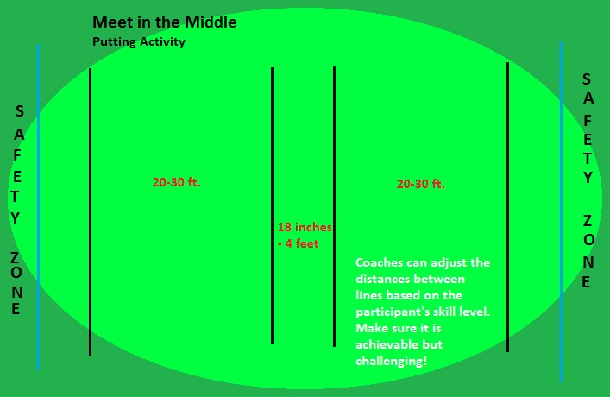

* **Hopscotch Putting**- Set up a Hopscotch type grid. Players may start on both ends. Must putt to first square before putting to subsequent squares. PLAYers putt from the “tee box” (cones) which is placed 2-6 feet from first square depending on level. They continue to putt from the tee box and progress from square to square. First participant to putt to all squares wins!

Safety Zone

* **Putting for pennies -** A row of cones is set up on the putting green. Participants must start between cones. Pennies are randomly set out approximately four club lengths from the cones. Players use correct aiming to hit a penny with their tennis ball. Players must judge if their ball hit the penny or not. If they hit the penny, they get to keep it.

## Last One Standing – Set-up: Line across the putting green, 2 cones about 25’ from line. (If you have space use both sides of the line so players can putt toward the line form both directions.) Players set up in a line between the cones and the Coach will say “1-2-3 Putt”. All players putt at the same time, anyone early or late (coaches judgment) can be eliminated from the round. Depending on size of the group the farthest 1,2 or 3 players are eliminated. (Opposite side can be consolation round) Continue until there is a Last One Standing

* **Tic-Tac-Toe:** Use flagging tape or tape stripes to set up grid. Play from a variety of distances to add/reduce difficulty. Participants of different skill abilities may play from different teeing areas.

**Tic-Tac-Toe VARIATIONS**

1. **Putt-in-a-Row –** Set up a tic-tac-toe grid and give players a challenge to putt 3 in a row, vertically, horizontally or diagonally. This can be an alternate shot or individual challenge. Add Personal Par as a life skill, how may balls will it take you to get 3 in a row? OR If you have 10 putts, how many squares can you fill with a ball?
2. **Reverse -** Place a tee in each square. When a player’s ball goes into that square they remove the tee. How quickly can you clear the board? Set up 2 boards and play match play for the first person or team to “Clear their board”.
3. **Specific** - Designate SPECIFICALLY how a tic-tac-toe game can be won. Must be diagonal, vertical or horizontal. This can tie into Goal Setting (Specific) or pick your own game, (Important to You) or even at PAR level Core Lesson #10, GAME. Which version of tic-tac-toe do you prefer?
4. **Center Wins** – Play traditional tic-tac-toe **EXCEPT** place a marker in the very center of each square. If two players or teams each putt to the same square, the ball closest to the center gets to keep/own the square.

* **Golf Curling**: Set up a Tee Box is 20-25 feet away from “HOUSE”

Each team has 6 like colored golf balls. Line 7-10 feet from hole, ball must pass the line to be in play. Set up starting places along an arc so players can choose different starting angles.

Object is

* **21 VARIATION**– This putting game rewards getting the ball to the hole. Players earn 2 points for a putt made, 1 point if the ball reaches or goes past the hole. Players LOSE a point if their ball fails to reach the hole. Play to 21.

**Safety zone**

1 3 5 7 10

* **Ball off Tee Challenges -** Place balls on tees at various locations. Determine the winner by:
  + Designate points for knocking a ball off of the tee
  + Designating points for NOT knocking a ball off

of the tee .

* **Drawback –** This can be played a stroke or match play or alternate shot. They will play 18 holes (or however many holes are available) from varying lengths (10-40 feet). If the putt is made, record it as 1. If the putt is missed, pull the ball back one putter length away from the hole from the ball’s resting position and putt from there. This “pull-back” will happen after each missed putt. Record the score.
* **Lucky 7-** Set up a grid of different sizes.Players try to putt balls into 3 different spaces producing a score of “7”. Can play individually or as a team. Putts range from 3-12 feet.
* **Pac Man Putting -** Pac Man (or Ms. Pac Man) is played as a yellow golf ball and starts in a corner of the game board. The ‘Bad Guys’ start in the center of the game board and are played with multi-colored golf balls, or a different color from Pac Man.

Pac Man tries to collect white dots around the game board/maze without touching the boundary lines. Pac Man picks up white dots (poker chips or ball markers) as they are collected. If Pac Man touches a boundary line, they must put a chip back and replay from their previous spot. Pac Man also tries to avoid the Bad Guys.

The Bad Guys must putt through the game board without touching the boundaries or maze lines. Their objective is to catch Pac Man before they collect all of the chips.

PLAYer (Pac Man) and other PLAYers (Bad Guys) alternate shots. Only one person putts at a time. Each PLAYer has an opportunity to play as Pac Man. The PLAYer who collected the most chips wins.

**Equipment:** Duct tape lines or flagging tape, multi-colored golf balls, poker chips or ball markers

**Modifications:** Maze size can be modified for skill level of the participant

* **Grenade Putting –** Set up a ton of cones or obstacles between the starting point and hole or end line. Players try to get to the end line in as few putts as possible without hitting a “grenade” (cone). Coaches may discuss strategy with players such to how they can get to the other side.
* **Pizza Putting** – Objective:To putt all of the ingredients (colored golf balls) into the different size pizza targets. Use survey tape or yarn and tees to form three round pizza shapes on the green. Each pizza shape will be a different size. (If it is easier to make a rectangular shape the Pizza will be of the Sicilian variety!) Make starting putting zones with cones and make sure to create safety zones.
* Each participant will be given four different colored golf balls to designate the pizza toppings. Yellow = cheese, Green = peppers, Orange = sausage, Pink =pepperoni

1. The coach will decide how many of each ingredient will need to be putted into the Pizza target to complete that pizza.
2. Participants will rotate through the different sized pizzas with the designated ingredients per pizza in the fewest number of strokes.
3. The participant who completes the pizza in the fewest number of strokes wins that round.

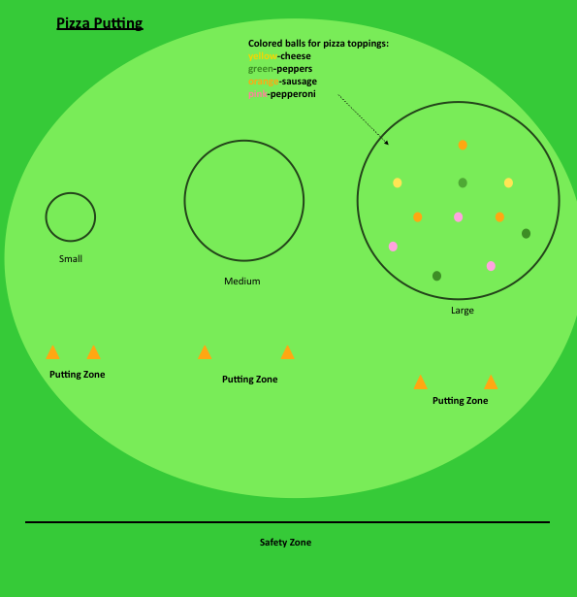

* **Partner putting** – Play in pairs, one partner is the Putter while their partner places a ball for the putter to strike. (at their discretion) The Putter’s goal is to make continuous strokes with the same Swing Rhythm. Round 1 – Putter will make the same length strokes with the same rhythm. Partner will randomly place a golf ball in the path of the putter as they continually swing back and forth. Discovery Moment: do all the balls end up in the same place? Round 2 – Putter makes different length strokes with the same Swing Rhythm. Partner randomly places a ball for the Putter to strike as the Putter makes continuous rhythmic strokes. Partner notices if Swing Rhythm changes with/without a ball.

* **Speed Putting** – How do you putt when the pace of play is faster? Break a class into 3 teams and line them up behind their team’s starting cone.  All putters are kept in front where they will be retrieved and returned for safety.  Create a rectangle of string as wide and deep as the skill of the students.  Place 3 cones in a slightly staggered line paced out based on the ability of the students.  In the race, the first person from each team **WALKS** safely, (without damaging the green) to the first cone and putts.  If the ball ends up in the putting box, they **WALK** back to the team, leave the club, tag in the next person and that person then putts from the second cone.  If a putt is too long or short, the next person must start over again at the first cone.  The first team to make all 3 putts in a row into the putting box wins!
* **Dodge Ball Putting** - 1) Create a large box using tees & string. This is the "dodge" area 2) Each PLAYer will "own" 1 colored golf ball and must toss it into the dodge area. Write Core Values on the balls so that each ball has one of The Nine Core Values on it. 3) PLAYers must putt from outside of the dodge area with a white golf ball. 4) PLAYers will play one at a time and try to hit a golf ball inside the dodge area.

5) When a ball gets hit it is removed from the dodge area. Last ball in wins!

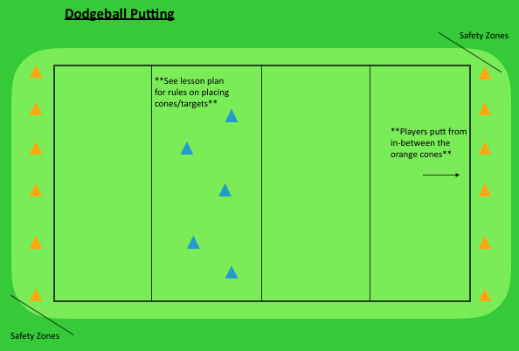

* **Sevens –** a fun match play putting game. The first player to seven wins. Use the following scoring system: 2 points for a putt made, 1 point for closest to the hole, -1 point if three or more putts
* **The Rules of “Knock on 3” or Poison-** The winner is the participant whose ball comes closest to the hole without going into the hole after everyone has putted three times. If a ball goes into the hole, that participant is out of the game.

The game begins with all participants in a straight line, aiming at the same hole. (25-40 feet)  On the count of three all participants hit their first putt simultaneously.  Remind them to watch their ball carefully, they are responsible to identify their ball.  After the first putt, play continues with the furthest from the hole putting first and continues until all players have putted three times.

**The Twist:**  Balls may not be moved or marked.  A participant may use their ball to hit someone else’s ball into the hole or to knock their ball away from the hole.

Tie in this game with STAR/ Dealing with Conflicts. (People in your way, putt your ball in the hole...)

* **Vocabulary Putting -** Setup a square target on center of putting green. Inside square put a smaller circle and inside circle put plastic letters of the alphabet. Setup stations 15 feet from target in circle or half circle, depending on # of participants. One at a time moving clockwise participants take turns putting at target, if ball stops in circle participants can choose 2 letters, if ball stops in outside square participants can choose 1 letter. Participant gets 1 putt. If putt is a miss, participant retrieves ball and returns to their station. First participant who spells a 4 letter word wins.
* Variations include changing the size of square & circle, number of putts allowed, length of putt and the length of the word. (3 or 5 letters)
* **Sharks and Minnows-** Participants all start with a colored golf ball and pick a starting point inside the ocean. (designated area made of marking tape) A coach will start as the great white shark (white golf ball) in a designated box outside the ocean.

Coach says, “Minnows swim away!” Players then hit one putt (must be length of putter grip) anywhere inside the ocean. Minnows all step out and then the shark gets a putt. Keep repeating the process. Goal of game is to be last minnow in the ocean.

Ways to get out: 1. Shark hits a minnow 2. Minnow putts outside the ocean 3. Minnow putts into the “black hole” (golf hole)

* **Cow Pasture Pool:** PLAYer and Par group will break up into teams of two. The goal of the exercise is to knock your team’s colored balls into the designated targets.

Team members will alternate turns with teams and partners to knock in all their balls in the pockets. This exercise is like regular pool. Construct pasture or with one hole cut in the general center of it.

* **Putting Ladder** (pairs nicely with a Goal Ladder) – using the same rhythm can you putt balls progressively in each step up the ladder?
* **3 Tees –** Each tee represents a “life”. This is a match play game against one other player. Each player will start on opposite sides of the hole 2’ or 3’ feet away. (Depending on skill level) One player putts until they make, then the next player will putt. If both make on their first try, they both move back 2’ farther form the hole and repeat. When one player misses a putt, they lose a “life”, (tee) and re-putts. If they miss again, they lose another life. After their last tee is gone, they continue to play but are eliminated when they miss an additional putt.
* **Jousting** - Players will knock over their partner’s cup and be the first to score 7 points.

**Supplies:** Lightweight cups (plastic solo cups, fast food cups, empty soda can, or Styrofoam cups work great), golf balls, putters

Each player puts a cup down on the green, so they are about 10-15 feet apart. (More advanced players can go 15-18 feet apart). Players stand even with their targets. Both players count down “3, 2, 1 putt” and each person putts to hit the other players cup. Players should try to putt at the same time.

**Scoring:** Players get one point for hitting the opponent’s cup. Players get two points if they hit their opponents target and the golf balls stays within one putter length of the cup.

**Coach Notes:** encourage participants to think about swing rhythm and how it is helpful in distance response.

* **2 Tee Putting Gate -** Place 2 tees in front of ball along the intended path of the putt. The tees will act as a “gate” for the ball to travel through. After putting several breaking putts using the gate, determine if the PLAYer is estimating an appropriate amount of curvature. Encourage the PLAYers to consider the following questions: How aware are you that the gate is “out there”? How well do you estimate the break or curvature? Do you need to adjust the gates and intended break? (see pictures below)

**PLAYer’s are encouraged to think about how THEY “see” the putt.** Do they see it as a straight line or a curved arc? A straight-line player might think about the distance of break such as 2-3 inches, “3 balls out”, or 1 cup to the right or left of the hole. A persona who sees the curve might think more about, “How do I want the ball to enter the hole?” Curved putters tend to see the whole arc or at least the apex.

* Putting Duel – Set up a strip of flagging tape down on green (6-10 ft. long) Participants start with handshake and stand back to back on either side of l the line.  One player decides how many steps they want to take (switch each time).  Players take the designated number of big steps and then stop and place their ball.  Players will putt to the line at the same time and whoever’s ball stops closest to the line is the winner.  Players repeat and play “best out of” competition.
* Putting for Dough - Coach sets up coins around a hole.  Pennies are closest, then nickels, then dimes and then quarters.  Player gets to keep the coin if they one putt.  Player leaves the coin where it is if they two putt.  Player putts the coin back in the box or gives it to the coach if they 3-putt.  Players can either keep the real change or play as a competition to see who wins the most money (gives it back but earns prize).

**Putt, Chip & Pitch activities**

* **Football Putting, chipping and pitching -** Set up a series of lines for “first downs”. Players must make a first down before they attempt to play to next section.
* **SNAG Football**- Design a football field using cones, and maybe string for yardage markers. Start at 50-yard marker and proceed- Have participants tee balls and pitch into the 50-40 yard zone. If successful, then pitch to 40-30 while remaining at 50-yard marker. Continue to land ball in each successive 10-yard zone until successfully landing SNAG ball in the end zone. First team to end zone wins, and/or the least amount of strokes!!
* **Pick your spot** - *Note: This game may be used for distance response or target awareness.* Equipment Required: Colored Discs & Balls. 1) PLAYer chooses a target or hole, 2) Choose club to pitch or chip 3) Place a colored disc near their intended landing area 4) Play their intended shot and observe outcome 5) If the PLAYer chooses to adjust their landing area based on previous outcome, place another different colored disc in new landing area and replay their shot. 6) Replay and change clubs or target and add another different colored disc to create a new target area.
* **Tee Chip –** On the greenset up a series of tees 3’ -4’ apart. Players will chip or pitch a ball to land as close to the tee as possible, each time progressing to a farther tee. Players may stay with the same club or change clubs within the game.
* **Eyes Open/Closed -** Roll putts and hit shots with eyes closed while visualizing or feeling connected to the target. Experiment with different lies and how slope and loft can affect the aiming point or initial line for putting and longer swings; finding the “straight putt” line is critical to green reading and the farther the ball lies from the straight putt, the more break will be present. **Variation/progression: players putt to a target whole looking at the target instead of the ball.**
* **Leap Frog-** Players can putt, chip or pitch form their starting point. They must play a ball past the starting line (zone) to qualify that ball. Play another ball that “passes” the first ball. Continue passing previous shot until you reach the end line. (OB) Balls that fall short of the previous shot do not qualify. They can be a “no count” ball or they can end the game.
* **Reverse Leap Frog** – Play the first shot as close as possible to the far border, each successive ball must stop short of the previous ball.
* **SNAG Football**- Design a football field using cones, and maybe string for yardage markers. Start at 50-yard marker and proceed- Have participants tee balls and pitch into the 50-40 yard zone. If successful, then pitch to 40-30 while remaining at 50-yard marker. Continue to land ball in each successive 10-yard zone until successfully landing SNAG ball in the end zone. First team to end zone wins, and/or the least amount of strokes!!
* **Tee Chip –** On the greenset up a series of tees 3’ -4’ apart. Players will chip or pitch a ball to land as close to the tee as possible, each time progressing to a farther tee. Players may stay with the same club or change clubs within the game.
* **21 putting or chipping-** Set up three different distances with various point values. 1-3-5 points. Players earn points by playing into each zone. A score of 21 wins. **Variation: 1-5-7 points and challenge players to get to 21 in as few attempts as possible. Establish consequences if the player’s putt roll past the high point zone. (Player loses 5 points)**
* **Chip-Tac-Toe – SEE Tic-Tac-Toe under PUTTING VARIATIONS.**
* **Pyramid Putting/chipping** - Station is set up like a pyramid. Can also play Lucky 7 with this set up. Players must first putt to first level before trying to reach the top of the pyramid.
* **Ski Ball – (**Like the game played at the Fair.) Set up 4-6 targets in succession for players to pitch into or onto. Each player plays 6 shots at the ski ball “holes” trying to accumulate as many points as possible. Once total points are tallied up, the group will then be paired off to play a best of 3 match against an opponent. Players will be seeded based on their score to create a small tournament. Whoever wins 2 of the 3 games in each match will advance to the next match until an overall winner is declared. They will be declared the Pitching Ski Ball Champion!!
* **21 putting or chipping-** Set up three different distances with various point values. 1-3-5 points. Players earn points by playing into each zone. A score of 21 wins. **Variation: 1-5-7 points and challenge players to get to 21 in as few attempts as possible. Establish consequences if the player’s putt roll past the high point zone. (Player loses 5 points)**

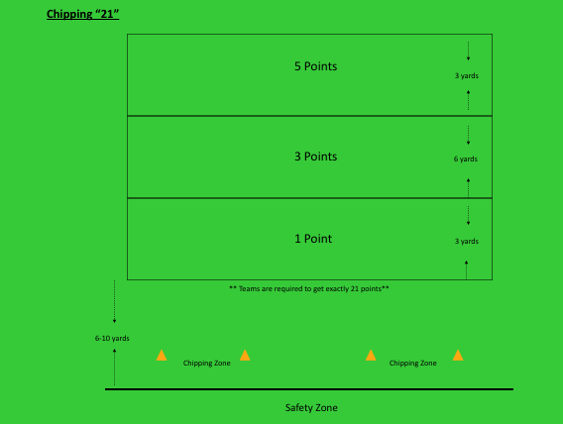

* **Pink Ball chip or putt –** (Any colored ball) Randomly toss the ball & all players putt, chip or pitch to it. Person who is closest gets a point and then they are in charge of putting or chipping the colored ball to a distance for everyone to play to. Variations include putting a cone out for chipping/pitching & playing “closest to” for points. Change the placement of the cone each time.
* **Field Goals -** Break players into teams of four. Each player gets 2 attempts to hit his or her ball through the upright (like a field goal) Scoring: 0 points for making a field goal, 1 point for bottom of the goal, Misses to the side but reaches goal-2 points, Doesn't reach the goal-3 points. Low Score wins!
* **Battleship VARIATION: Bocce Ball -** Play as 2 teams or 2 individuals against each other. MATCH PLAY

Objective to get close to the pallino (target) which is a different colored ball than the game balls. Toss/roll the Pallino into field on play (green for putting or chipping) Take turns tossing, putting or chipping a ball to get close to the “pallino”

Bocce Rules: Once a pallino is in play it can be knocked anywhere on the “court”. (not off the court)

* Initial Pallino thrower always plays the first Bocce ball. (Chips, Putts first)
* Next team plays their shot and whichever team is CLOSEST to the Pallino plays next.
* Continue until each team has played their 4 balls.

SCORING Option 1: Closest to Pallino earns 1 point, next earns 2 points, 3rd closest gets 3 points….etc. Add scores for each team, lowest point total wins.

SCORING Option 2: One point is awarded for each ball of a team that is closer to the pallino than the opponent’s closest ball (1 to 4 points) If each team’s closest balls are tied, no score is made and play continues at the opposite end with the team scoring the point(s) in the previous frame delivering the pallino. The team that first scores 12 points, wins the game.

Can be played with SNAG or traditional golf equipment.

Equipment: 1 ball of different color. Two sets of 4 like colored balls.

**Can use Soccer balls as an Object Control warm-up activity.

See picture next page

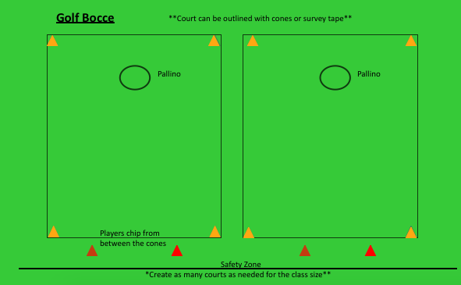

* **Memory-** PLAYers putt or chip their balls into target zones in an attempt to collect the most pairs of matching cards. This game not only challenges PLAYer’s golf abilities but asks them to remember what is hiding in each zone at the same time.

As individuals or teams, PLAYers attempt to have their balls stop in specific target zones. When PLAYers hit a target zone they may turn over its card. They then gain another attempt to hit an additional target. If they find a match they can collect the pair and continue their turn. If PLAYers miss or no match is found, they must turn both cards back over, and their turn is finished.

Memory is a good game to reinforce golf rules, areas of the golf course, Life Skills and Core Values as card items. This game may use as many pairs of cards as desired, but no less than 3.

Cards may be left turned over once exposed in order to speed up play r depending on the skill level of the players. (See Picture)

Memory Set-up:

? ? ? ?

? ? ? ?

**? ? ? ?**

* **Lily Pad –** Putt, chip, or pitch to different size targets or circles set at various distances. . They can all have the same point value or you can vary point values depending on level of challenge. This can be played as a team game, first team to get a ball on each Lily Pad, (or target area) or individually with the player getting “up & down” (putting into the hole once on the Lily Pad) a certain percentage of time. This is a good pairing with Goal Setting.
* **Grid Challenge -** With a 3-4 lane grid made of tape, noodles, and target circles, players try to score points by hitting in certain areas. Players’ focus on how many points they can score. Bonus points awarded if make into the target circle. (50-90yds).

* Putt or chip with a rubber band on the toe and heel of the club- essentially reducing the clubface so that only a centered impact will produce a straight shot.
* **Battleship Putting** **or Chipping** - Each team will try to sink the ships of the opposing team. Each team needs to putt or chip a ball into the sections of each of the front ships before aiming the battleship.

**Supplies:** cones, putters, golf balls, survey tape and tees

**Description of Set-Up:** Use tees and survey tape or yarn to make the battleships. If putting use S noodles to keep balls from rolling into the other team’s ships. Cones to designate the putting areas and safety zones.

Each team will be assigned one side of the putting green. There will be multiple putting stations on each side but there will still be participants in the safety zone.

Each team has an assigned coach to help retrieve the balls and help each team. This is a race to see which team can sink the other team’s ships first.

Both teams will start at the same time and the first team to sink all three ships is the winner.

The teams have to sink the front two ships first before trying to sink the three section battleship.

Play multiple rounds if time permits and have the teams switch sides between each round.

Make the game harder or easier by making the ships larger or smaller and adjusting the distance from the putting station to the ships.

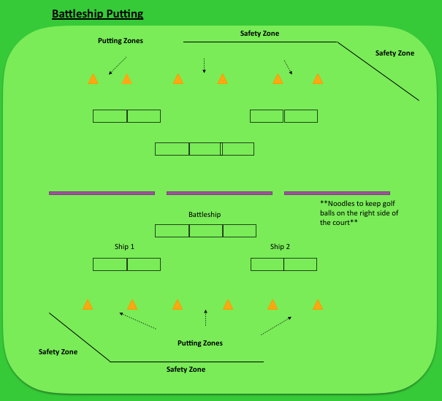

**Battleship Variation –** Add complexity to the game by creating **“NO GO” zones or interferences** (cones) within the game. PLAYer must use a pre-shot or STAR to consider the consequences of accidentally hitting a “No Go” Zone. Create consequences for hitting a “No Go” spot depending on the skill level ranging from loss of a ship or clearing the board of all of the ships your team has sunk to that point.

Battleship Chipping Set-up

* **Grip & Greet –** Give players a scale of 1-5: 1 is barely touching, 2 is holding a baby bird, 3 is holding a tube of toothpaste without squeezing any out, 4 is squeezing a little of the toothpaste out, 5 is gripping tight like you don’t want to let go. Players meet each other and shake hands. Have a conversation where each player tells the other what number they would say their grip is. Practice using different grip tensions to create awareness.
* **Partner Toss** - Toss SNAG balls back and forth. The coach calls out numbers 1-5 for how tightly you must hold the ball before throwing. How does grip tension impact your throwing ability? Tie that into tension/hold of golf club.
* **Chip or pitch with Rhythm** – place a spot on the ground where you believe your pitch or chip should land in order to finish near the target. Practice rhythmic swings before playing shot. Imagine where the ball would land and finish with each swing. If your image and the landing area do not match you can adjust your landing target before hitting your shot. Play your shot focusing on the rhythm you practiced and notice the outcome. If the ball does not finish near your target, what would you adjust?
* **Bucket –** Pitch balls from various distances. How many out of 10 can you get into the bucket? Trashcan lids work great too & make a ton of noise when hit.
* **Asking and Trusting Game**

This putting game emphasizes communication between PLAYers as they work together to be the team that scores the most points on a putting course. On each team of two, one PLAYer will act as a “Helper” who guides their blindfolded teammate who is the “Golfer” around the course and to success.

* Set up a putting course (3, 6 or 9 hole) with holes of various length. Divide PLAYers into teams of two and allow them to walk the course prior to playing it to become familiar with each hole. One PLAYer is the blindfolded Golfer while to other PLAYer is the Helper
* Round 1: The Helper can only place the ball in front of the putter face and offer no help except to say “You are set”.
* Round 2: The PLAYer is allowed to have the Helper assist. For example – adjust aim, give information about distance, etc.
* PLAYers can switch roles and repeat rounds one and two. Combine both scores at the end for a total score.
* PLAYers may play just for the experience and share their thoughts together as a group afterward. Can be played for points using bull's-eye target zones of different point values. The team with the most points wins.
* **SET-UP Materials: Cones for teeing area & Safety zones, Target Zones or golf holes for targets, Putters, Balls, Bandanas/blindfolds, scorecards and pencils.**
* **Croquet Chipping -** Supplies: alignment sticks, noodles, pitching wedge, almost golf balls (real golf balls work perfectly fine too)

Set up: Using the alignment sticks, create an arch with the noodles by stabbing each side of the noodle to hold it down. Use the noodles as the Croquet Arches. Set up two separate lines of arches, so that one team uses one set of arches, and the other team uses the other set of arches

The Game: Participants will be in partners, they must go underneath each arch, count the number of strokes it takes them to get to the end. They play with one ball, alternate shot with their partner. It is also a race, so they are learning pace of play, but also taking their time to make a good shot so that they have the fewest number of strokes.

* **UP & Down Best Ball/Worst Ball** – Play 2 ball for an up and down try. One time select the BEST of the 2 shots onto the green. Alternate and the next time select the WORST of the two shots onto the green. In all cases putt out for score.
* **Chip or pitch with Rhythm** – place a spot on the ground where you believe your pitch or chip should land in order to finish near the target. Practice rhythmic swings before playing shot. Imagine where the ball would land and finish with each swing. If your image and the landing area do not match you can adjust your landing target before hitting your shot. Play your shot focusing on the rhythm you practiced and notice the outcome. If the ball does not finish near your target, what would you adjust?
* **Putt, Chip or Pitch Match Play –** Set up 3-5 holes with target circles for the game**.** Players each have 2 balls to get into each target circle. Round 1 both players hit their two balls. If Player A gets 1 ball in the circle and Player B gets both balls into the circle then Player A must stay at Hole 1 until they get their second ball in while Player B gets to advance to hole #2. The catch is that you DO NOT get to play continuously. Each player only gets to hit 2 balls at a time! (Take turns) Continue until one player successfully gets 2 balls into each target circle. Increase the challenge by changing the distances or by increasing the number of balls to 3 per player.
* **Short Game Match Play Variations:**
* Coaches set up a putting, chipping, or short pitching course providing a variety of shots and difficulty. Pair PLAYers with a partner, all pairings will rotate through the course in order. PLAYers determine who goes first per the Rules of Golf, play Match PLAY until a winner is determined.
* PLAYers may play in larger groups assigning points for the first, second and third closest PLAYers with the most points at the completion of the course winning.
* –PLAYers may play in teams working together to best another team in either match play or points.
* –The game may be played in an elimination style format with the furthest PLAYer from the hole being eliminated. Eliminated PLAYers may still participate, and can be allowed back into the competition if their ball is the closest to the target on any of the following holes. The game is completed when all but one PLAYer is eliminated.

Set the ball is deep down in grass. Do you need a steeper swing into impact or a shallow (Y to Y) swing? (Steeper!) How do you make the swing steeper? Ball position slightly back (under right eye) and weight 60% on front (left) foot. If the ball is on light grass, how do you play the shot? Sweeping chip? Move around the green and hit from different lies.

* **ALL Clubs/One Club –** chip to one specific target using EVERY club in your bag. Then select ONE CLUB and play to various targets. Consider the adjustments you have to make for both challenges.
* **Elimination Challenge Putting, Chipping or Pitching:** ALL Players all play to one target. Player farthest from the target is “ELIMINATED” and has to go to the ELIMINATION STATION while remaining players continue hitting shots and eliminating players. While at the ELIMINATION STATION players will play to a designated target area, (White wire rings) until they get a ball into the target area. If they get into the target area they can then return to the original Challenge. Winner is (are) player(s) at original Challenge at end of time. Stop after 10 min & have a coach moment- How are you reacting? Are you using your pre-shot routine or rushing?
* **Trajectory for Points:** Create your own game using this basic concept: Firstestablish a tee box and general target zone. Throw (overhand, underhand and roll) or use a club to play a ball to the target zone. Sample Game: a chip must travel underneath a rope that is placed three or so feet off of ground. One point is awarded if the ball just gets air born, two points are awarded if the ball goes under the rope, and three points are awarded if the ball goes under the rope and within 20’ of the hole. Next, proceed to a pitching game OVER a bunker where a point is awarded for shots that clear the bunker regardless of where they end up; two points are awarded if the ball clears the bunker and stops on the green.
* **Birds on A Wire -** Set up: Coaches stick two alignment sticks in the fringe of the practice green about 6 feet apart. They then tie a string between the two alignment sticks.  Place an inflatable parrot (from the dollar store) on the string.  Place cones for the hitting area about 6-8 feet back from the bird. PLAYers will attempt to hit a chip shot knocking the "Bird" off the "Wire".  After each player has had two turns at that station they will rotate to the next station where the will repeat.  Set up several stations, each can have a slightly different challenge: distance from hitting zone to target; uphill/downhill lie; fairway or rough.  (See picture.)
* **That’s Good–** Select 6-8 locations to play to the hole from around the green including various lies and terrain conditions. Using Goal Setting criteria or Personal Par pre-establish a “That’s Good Zone”. Play each shot to the hole. When your ball finishes in your That’s Good Zone then that ball is eliminated. Continue playing until all balls are good. Score yourself by how many total balls it takes to be ALL GOOD!
* **Handicap –** Putt, chip, or pitch 7 balls to a target. Eliminate the closest and the farthest 3 balls. Measure the “in between ball” and that number is your handicap for that shot. Create handicap for your short, medium and long putts, and for short medium and long pitches and chips.

* **Over/Under Challenges -** Allow PLAYers to discover various ways to chip and pitch balls to go over or under the various noodles using their club of preference. For more advanced players, coaches or partners can dictate the club selection for the challenge OR ADD a target circle end point.

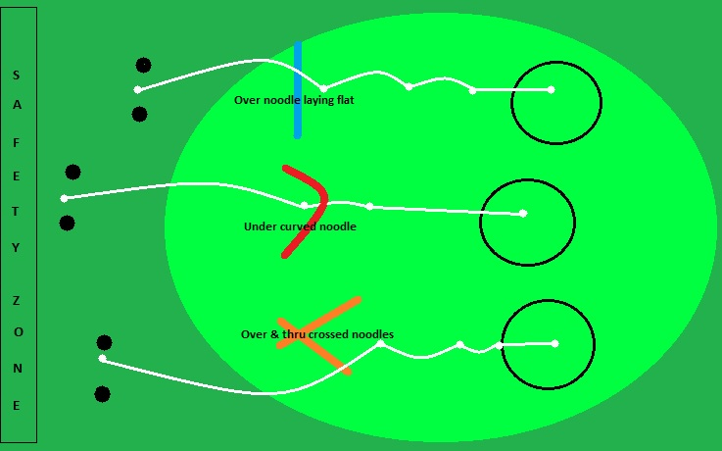

* **Pitching for points or Bombs Away** Equipment: Assortment of wedges, noodles, alignment sticks, poker chips or shipping tube caps or anything that will flip when hit, whiffle balls, range balls, tennis balls and a fairly large landing area. (Plus all of the normal safety zone and starting location equipment.)

Setup: Have stations of varying heights using the noodles and alignment rods (or other items) set up. Starting point should be at least 10’ from the targets. Randomly place the targets from 10 to 30’ away. Appropriate safety zones.

The Game: Players attempt to flip the targets by landing their shots on them. Various games can be incorporated such as 2/3/4 person teams accumulating “points” for flipping the targets with different points being assigned to targets based on color or distance. Both the type and number of balls hit in each rotation is based on the player level. Balls are only retrieved after all balls have been hit. If whiffle balls and caps are used a bonus can to awarded for getting the ball to stop on the cap. Players rotate through all the stations until all players have been through each station.

**FULL SWING:**

* Feet provide basis for balance; do balance tests and play games that connect other sports and fundamental motors skill to being balanced in golf.
* Know what balanced posture looks like for you. Use a mirror to give a picture. Use a club to “measure” how far apart your feet are and how far your shoulders are in front of your toes.
* Swing as hard as you can and hold follow-through position until the ball stops rolling.
* Introduce exercises that promote balance such as hitting with one hand or standing on one foot, “rear foot toe top, hold finish position,” “feet together,” walk through to the finish (Gary Player), and “balance boards.”
* Practice various lies (uphill, downhill, side hill); notice how balance changes at set-up and during motion.
* Swing with eyes closed to increase balance awareness prior, during and after each shot.
* Learn to stay in balance on uneven surfaces via realistic golf course situations.
* **Bunker Play –** In a bunker youcan think of Ball Contact several ways: splash sand onto the green, make a ‘moat’ around the ball and splash the moat, make a small castle for the ball to sit on and destroy the castle, imagine the ball on the center of a dollar bill and splash the whole dollar bill.
* **Face Awareness –** Players work in pairs. Player 1 will close their eyes and hold a club VERY LIGHTLY with the club horizontal to the ground. Their partner will gently rotate the clubhead around in any direction, any amount. When they are finished they tell their partner “done” and Player 1 will tell their partner which direction the toe of the club is pointing. It is very helpful to use a clock as a reference. If the toe is pointing to the ground it is 6:00, if straight up to the sky then 12:00. Players get very accurate with practice. After a few tries, partners switch roles.
* **Talcum power**, masking tape, or dry erase marker on the clubface to see centeredness of contact.
* **Baseball golf -** Stand in the same stance and, by changing only the clubface, play to a target to the right, center, & left.
* Intentionally set your body to the right of the target, (or left) & adjust clubface at impact to play toward the target at impact.
* Set up several targets. **After** a player begins their swing, (1/4 backswing) their partner or coach calls out the direction to hit the shot. (Right, left center) For more advanced players the partner or coach can call out specific instructions such as “high right”.
* Demonstrate impact position by taking slow motion or tai chi full swings. Repeat the slow motion swings a certain number of times before actually striking a shot slowly. After several successful solid ball contacts, increase speed in small increments
* On the Range for full swing - use a tee to scratch a line in the grass in front of the ball. PLAYer will notice the location of their divot relative to the ball and scratched line. Goal: PLAYer hits the ball first then takes out the line.
* Learn how to make adjustments such as foot flare and width for different conditions.
* Explore your best swing speed to stay in balance & have solid contact
* Use different sports and fundamental motor skills to connect rhythm – including sequence of motion and tempo – to the golf swing. For example, throw a tennis ball as far as they can and then try to throw a tennis ball as far as they can without stepping into it. (Experience how using proper sequence enables them to throw the ball farther) Other examples: Baseball swing, Tennis Swing, Boxer Punching. Complete all motions from both sides of the body.
* Swing a basketball back and forward from a golf stance; then, throw the ball to each other, simulate golf swing.
* **Back swing vs. forward swing (e.g., “tic-toc” and “back-through”). How does the rhythm of the back swing and forward swing compare?**
* Swing opposite handed.
* Swing Rhythm Words- Count or say words during your swing to keep your mind off swing cues & to help rhythm. “Back-Hit” or try saying the words “one-two-three” – “one” for the back-swing, “two” for the down-swing and “three” for the follow-through. Other word cues can be a short phrase like “really smooth”.
* 3 to 5 continuous motion swings, three motions backswing to finish, backswing to finish, etc., without stopping.
* Where is swing the fastest to maximize distance? Whoosh Drill: Reverse club, hold head, take swings, and hear “swoosh.”
* Verbalize a word or phrase that matches rhythm and/or tempo of swing. (Hum or whistle or create a phrase to create a tempo and experience rhythm in their motion)
* Play “% swings” & discover how far ball travels. (1/4 speed, ½ speed, etc.). You can also use this game to focus on solid contact & balance.
* Change one thing at a time and discover how each influences ball trajectory and distance: ball position, weight distribution at address, shaft lean at address, hold pressure, and different clubs.
* Swing a basketball back and forward from a golf stance; then, throw the ball to each other, simulate golf swing.
* **Back swing vs. forward swing (e.g., “tic-toc” and “back-through”). How does the rhythm of the back swing and forward swing compare?**
* Change one thing at a time and discover how each influences ball trajectory and distance: ball position, weight distribution at address, shaft lean at address, hold pressure, and different clubs.
* **One, Two, Follow Through-** Focus is on balance. Players will say, “1, 2 Follow through or “Front Foot doesn't move, 1, 2, Follow through”. Players switch with partners.
* **Swim Noodle Balance**- Use a swim noodle to practice balance challenges. Experience balance by first placing the noodle under one foot while trying to hit. Players may then stand on the noodle, trying to push down into the ground which helps promote an athletic setup.
* **Interesting/Fascinating –** Set up a line directly behind hitting area. (Inside the safety line) Players will play their shot and, while the ball is in the air or still moving, will move behind the line as if a spectator of their own shot. Regardless of the outcome of the shot, the player will say “interesting” or “fascinating” practicing a neutral response.
* **MIND- Inner Caddy**- If you were caddying for “you”, how would you talk to “you”? Golf lets you practice keeping a positive attitude, understanding where your focus is and how long you can maintain it, staying in the present, and generally how to face adversity- all challenges we experience in life.
* **Challenge lies.** Set up a series of very difficult lies and ask player to process through pre-swing adjustments they can do to accommodate them. How do you create a plan?
* **See it, Trust it** – Good for Chipping or Pitching. Players pick a hole and a target landing area. Take practice swings to feel and imagine the distance of your shot and specific landing area. Place a target in your intended landing area. Go through your pre-shot routine and play the shot BUT DO NOT look at the ball as it lands. Tell your YOUR PARTNER if you think you landed before, on, or after your target landing area.
* **Time Pre-Shot –** Work in partners or use a metronome to count the of a player’s pre-shot routine. How consistent is it for length of time? Discover your best way to play – tie into diversity.
* **Super Hero Knock-off –** Coaches place fun head-covers on top of PVC stand or even on top of a series of boxes. From 10-20 yds. away, players pick a club or adjust ball position to hit the right trajectory and try to knock the head-covers off the stand.
* **Play Frisbee golf.** Focusing on ball flight and curvature. Using Frisbee golf discs makes it really easy for the participants to see the impact of swing path on curvature, along with weight distribution and more.
* **One Club -** Use the same club but learn to hit it high, medium and low.
* Use colored discs to represent path of club. Path can result in curvature when combined with face direction. The colored discs represent swing paths. Blue represents “in to out” and red represents “out to in” for right handed players. Many players prefer “in to in”.

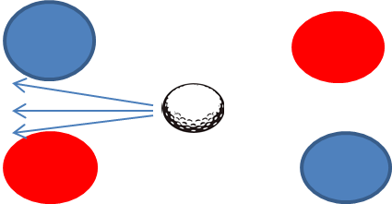

* **Obstacle -** Players try to hit a shot at a green or target with obstacles in front of them. Obstacle might be directly in front of player, behind, or to the side. Player must use STAR to determine if curving left or right, how to anticipate swing, etc. Players

alternate shots, creating a match play environment against each other with the player achieving their goal as getting a point.

* **Roll the Dice-** you can design this several ways to mimic On Course scenarios:

1) Write different shot types on each side of the dice and roll to see what you get to play. If you have a second die you can roll for number of attempts you have to do it.

2) Another option is to create different on course scenarios.

3) Play a shot from 6 different spots depending on the roll of the dice. Roll die to determine your spot, roll second die to determine which club to use. You can vary this by giving each player 2 shots, one determined by the dice, the other with their preferred club.

* **3 to One –** Hit three shots to the same target, EXCEPT you have to change one thing about each shot. (Speed/rhythm, club, ball flight….etc.) Use Personal Par to set a target distance BEFORE you begin the game. “All ball must finish within____ of the target.” Add pressure to the situation by giving yourself a limited number of ball to accomplish the game.
* **ONE PLAYER VARIATION Chip or Pitch Match Play –** If practicing solo, one player can play by keeping track of how many total balls it takes to play through the game as described above.
* **Play it as it Lies –** On the Range or for Short Game players work in partners. One partner tosses/rolls the ball into the hitting zone for their partner to play to a target. Add more challenge by giving the waiting partner the opportunity to choose the target.
* **PIG –** Remember the old basketball game where you make a shot and your opponent must make the same shot or they earn a letter? Play this game by adjusting the Game Name (PIG) to match your focus for the day. (For Goal Setting you might use the word SPECIFIC) Players can putt into the hole or pitch/chip into a target zone for the challenge.
* **TEE OFF –** In an 18 hole round there are typically 14 tee shots. Establish a fairway and play 14 Tee shots to determine how many you get in your fairway. Play again except this time after every tee shot you MUST hit an iron shot and then Tee Off again. Compare your stats with your no interruption tee shots and your iron shot interrupted tee shots.
* **POINTS – Similar to “That’s Good”** (above) This time set up scoring distances for each shot and an associated point value. For example you might get 10 points for making the shot, 7 for within 3’, 5 points for within 6 feet, 3 points for within 10 feet and one point for within 20 feet. If shots are more challenging change the distances for scoring points.
* **ROPE –** Play 3 shots to a target.Before playing give yourself the least amount of “rope” you think you need. **Your goal is to have the total of all balls finish within the distance of the rope.** For example if you give yourself 15 feet of rope and chip one ball to 5 feet, one ball to 6 feet. You will need to get your final chip within 4 feet so that you do not run out of rope.
* **5-3-1 (OR 9 Point Game) –** Play this game with 3 players. This can be played with skills challenges or On Course. For skills challenges the person whose shot is closest to the target receives 5 points, next closest is 3 points, and farthest gets 1 point. If playing On Course you play by awarding 5 points to the lowest score, 3 for the second lowest score and 1 point for the highest score. For ties add the 2 scores together and split. (For example, 2 tied for low score 5 + 3 = 8 so each person gets 4, if all 3 are tied for low score, the all receive 3 points.)
* **Odds or Evens –** Play the course with ½ of your clubs, either the odd number or even numbered clubs.
* **Can You Hit This? –** Play against yourself or with friends. Try unusual shots such as a super low sand wedge shot, a big high slice, a low hook, etc.
* **Alternate scoring games –** Play several holes and score yourself with the following games:

1. **Rough is Out of Bounds.** Play any shot that is in the rough by adding the stroke and distance penalty.
2. **2 clubs and a putter –** Play several holes with just 2 clubs and a putter
3. **Club elimination –** Designate several holes for the game. Players can choose the same number of clubs as the holes you are playing for the game PLUS your putter. Eliminate one club per hole so that you are playing the final hole with one club and a putter.
4. **Best Ball/Worst Ball –** Alternate holes. Odd holes play 2 balls and choose the best ball each time and play form that spot. Even holes play 2 balls and play your WORST ball each time and play form that spot.

* **Plus and Minus –** This can be a full swing game on the range or a short game challenge. Play each round with 5 balls and change clubs for each round. Play to a designated hole or target. For each shot the player deems “good” or up to their Personal Par they earn a point. For any shot they deem “not good” or below their Personal Par they subtract a point. Play 2,3 or 4 rounds and see how many points a player can earn.
* **Full Swing: Through the Gates-** Set up a “fairway” with noodles, players will hit through the gates. Focus is on accuracy. Variations: Wide to narrow, (The longer the shot, the more narrow it becomes.) or narrow to wide. (Closer requires more accuracy.)

**Warm-Up or non-golf activities:**

Ring Toss or Crowning the King

Equipment: Rings of varying diameter from 6“ to small hula-hoops. Cones or stakes at least 6” high. Safety zone indicators of choice. Starting zone indicators of choice.

Setup: Place cones or stakes a minimum of 4’ from starting position. Initial setup has cones/stakes in a straight line from each starting location set 2 or 3’ apart. Setup distances are subject to change based on the class level with targets being placed farther away as levels increase. Random target assignment adds difficulty and increases opportunity to discuss target awareness and alignment.

The Game: Players take a stance 90 degrees from the targets holding the ring perpendicular in their right hand in front of them. They then take the ring back rotating their hand so that the palm is facing up. They then toss the ring underhand rotating their hand so that the palm is facing down after release. The same process is done with the left hand with the palm direction reversed, down then up. The final tosses are done with both hands holding the ring and making the toss. Players start with the closest target and work their way to the furthest. Utilizing the random targets adds a lot of fun to the activity. Players are not allowed to retrieve the rings until all rings have been tossed. Players rotate through all stations until all players have been at each station.

**Warm up activity:** Participants form a circle. Give a ball to 2 individuals on opposite sides of the circle. The idea is to have them pass the ball as fast as they can around the circle seeing if they can catch up to the ball that started on the other side. This is done in both directions. Any size ball can be used. Large balls are usually passed using both hands. This can be played with balls as small as a golf ball. The smaller balls can be passed using one hand only and limiting it to either right or left. The interesting part of the exercise is to see how many individuals pass the small ball between his or her own hands before passing it to the next individual. With larger groups more balls can be introduced.

**Icebreaker/warm-up:**

LOOK UP/LOOK DOWN - Tie in with Meet and Greet (from Karl Rohnke FUNN STUFF)

* Participants form a small circle
* Coach will instruct the group to “look down”
* When the Coach says “Look UP”, everyone must look up at the same time & look directly in the eyes of another player
* Any pair that looks at each other is “out”. (anyone who delays is out as well) Continue until one (or two) players remain.

FILL ME IN - Tie in with Meet and Greet (from Karl Rohnke FUNN STUFF)

* Get in a circle approx. 10 yds. Across
* 1 person step into the circle announcing the name of another person directly across & walk toward the person
* “called out” person duplicates your action by calling out another person in the circle saying the name of another participant as they walk toward that person’s position. (each named person ends up walking toward another person’s position.
* Create eye contact with person whose name you called so they know they are the one to move out
* As speed increases there is a chaotic combination of crossings

FACE VALUE - Tie in with Meet and Greet (from Karl Rohnke FUNN STUFF)

* Line up with 2 single file lines face away from you in a “V” with leader in the Apex
* Leader at point of “V” taps shoulder of two people closest who turn around and closely observe your facial & body movement/expression.
* Those two turn back to their original positions & tap shoulder of the next person in their line & reproduce the original presentation of leader.
* The two lines pass along whatever the first person started. When the final pair has “taken a look”, they represent the action to the whole group.

Have first person demonstrate to the group the original movement & compare